IBM PHASE 3 PROJECT
COVID-19 DATA ANALYSIS

Team members
- Mohammed salman.H
- Syed waseemuddin
- Syed Hussain
- Noor ibrahim.H
SHORT INFORMATION ABOUT PROJECT

In total vaccination the null values are given the minimum value using mean.

below barplot is used to visualize countries with max vaccinations.

another barpplot is used to show countries with max full vaccinations.

vaccine types are print to know how many vaccines are given in data set.

using counterplot which vaccine is mostly used is visualized and difference is shown using the same graph.

daily vaccinations and total vaccination count is shown using lineplot and like this using so many graphs every data column is visualized.

Daily vaccination and total vaccination is compared between top vaccinated countries usng lineplot.

#importing essential libraries
import pandas as pd
import numpy as np
import matplotlib.pyplot as plt
import seaborn as sns
#import warnings
#warnings.filterwarnings("ignore")
#reading dataset
df= pd.read_csv("country_vaccinations.csv")
df.head(15)
country iso_code date total_vaccinations people_vaccinated \
0 Afghanistan AFG 2021-02-22 0.0 0.0
1 Afghanistan AFG 2021-02-23 NaN NaN
2 Afghanistan AFG 2021-02-24 NaN NaN
3 Afghanistan AFG 2021-02-25 NaN NaN
4 Afghanistan AFG 2021-02-26 NaN NaN
5 Afghanistan AFG 2021-02-27 NaN NaN
6 Afghanistan AFG 2021-02-28 8200.0 8200.0
7 Afghanistan AFG 2021-03-01 NaN NaN
8 Afghanistan AFG 2021-03-02 NaN NaN
9 Afghanistan AFG 2021-03-03 NaN NaN
10 Afghanistan AFG 2021-03-04 NaN NaN
11 Afghanistan AFG 2021-03-05 NaN NaN
12 Afghanistan AFG 2021-03-06 NaN NaN
13 Afghanistan AFG 2021-03-07 NaN NaN
14 Afghanistan AFG 2021-03-08 NaN NaN
people_fully_vaccinated daily_vaccinations_raw daily_vaccinations \
0 NaN NaN NaN
1 NaN NaN 1367.0
2 NaN NaN 1367.0
3 NaN NaN 1367.0
4 NaN NaN 1367.0
5 NaN NaN 1367.0
6 NaN NaN 1367.0
7 NaN NaN 1580.0
8 NaN NaN 1794.0
9 NaN NaN 2008.0
10 NaN NaN 2221.0
11 NaN NaN 2435.0
12 NaN NaN 2649.0
13 NaN NaN 2862.0
14 NaN NaN 2862.0
total_vaccinations_per_hundred people_vaccinated_per_hundred \
0 0.00 0.00
1 NaN NaN
2 NaN NaN
3 NaN NaN
4 NaN NaN
5 NaN NaN
6 0.02 0.02
7 NaN NaN
8 NaN NaN
9 NaN NaN
10 NaN NaN
11 NaN NaN
12 NaN NaN
13 NaN NaN
14 NaN NaN
people_fully_vaccinated_per_hundred daily_vaccinations_per_million \
0 NaN NaN
1 NaN 34.0
2 NaN 34.0
3 NaN 34.0
4 NaN 34.0
5 NaN 34.0
6 NaN 34.0
7 NaN 40.0
8 NaN 45.0
9 NaN 50.0
10 NaN 56.0
11 NaN 61.0
12 NaN 66.0
13 NaN 72.0
14 NaN 72.0
vaccines \
0 Johnson&Johnson, Oxford/AstraZeneca, Pfizer/Bi...
1 Johnson&Johnson, Oxford/AstraZeneca, Pfizer/Bi...
2 Johnson&Johnson, Oxford/AstraZeneca, Pfizer/Bi...
3 Johnson&Johnson, Oxford/AstraZeneca, Pfizer/Bi...
4 Johnson&Johnson, Oxford/AstraZeneca, Pfizer/Bi...
5 Johnson&Johnson, Oxford/AstraZeneca, Pfizer/Bi...
6 Johnson&Johnson, Oxford/AstraZeneca, Pfizer/Bi...
7 Johnson&Johnson, Oxford/AstraZeneca, Pfizer/Bi...
8 Johnson&Johnson, Oxford/AstraZeneca, Pfizer/Bi...
9 Johnson&Johnson, Oxford/AstraZeneca, Pfizer/Bi...
10 Johnson&Johnson, Oxford/AstraZeneca, Pfizer/Bi...
11 Johnson&Johnson, Oxford/AstraZeneca, Pfizer/Bi...
12 Johnson&Johnson, Oxford/AstraZeneca, Pfizer/Bi...
13 Johnson&Johnson, Oxford/AstraZeneca, Pfizer/Bi...
14 Johnson&Johnson, Oxford/AstraZeneca, Pfizer/Bi...
source_name source_website
0 World Health Organization https://covid19.who.int/
1 World Health Organization https://covid19.who.int/
2 World Health Organization https://covid19.who.int/
3 World Health Organization https://covid19.who.int/
4 World Health Organization https://covid19.who.int/
5 World Health Organization https://covid19.who.int/
6 World Health Organization https://covid19.who.int/
7 World Health Organization https://covid19.who.int/
8 World Health Organization https://covid19.who.int/
9 World Health Organization https://covid19.who.int/
10 World Health Organization https://covid19.who.int/
11 World Health Organization https://covid19.who.int/
12 World Health Organization https://covid19.who.int/
13 World Health Organization https://covid19.who.int/
14 World Health Organization https://covid19.who.int/
df.describe()
total_vaccinations people_vaccinated people_fully_vaccinated \
count 4.360700e+04 4.129400e+04 3.880200e+04
mean 4.592964e+07 1.770508e+07 1.413830e+07
std 2.246004e+08 7.078731e+07 5.713920e+07
min 0.000000e+00 0.000000e+00 1.000000e+00
25% 5.264100e+05 3.494642e+05 2.439622e+05
50% 3.590096e+06 2.187310e+06 1.722140e+06
75% 1.701230e+07 9.152520e+06 7.559870e+06
max 3.263129e+09 1.275541e+09 1.240777e+09
daily_vaccinations_raw daily_vaccinations \
count 3.536200e+04 8.621300e+04
mean 2.705996e+05 1.313055e+05
std 1.212427e+06 7.682388e+05
min 0.000000e+00 0.000000e+00
25% 4.668000e+03 9.000000e+02
50% 2.530900e+04 7.343000e+03
75% 1.234925e+05 4.409800e+04
max 2.474100e+07 2.242429e+07
total_vaccinations_per_hundred people_vaccinated_per_hundred \
count 43607.000000 41294.000000
mean 80.188543 40.927317
std 67.913577 29.290759
min 0.000000 0.000000
25% 16.050000 11.370000
50% 67.520000 41.435000
75% 132.735000 67.910000
max 345.370000 124.760000
people_fully_vaccinated_per_hundred daily_vaccinations_per_million
count 38802.000000 86213.000000
mean 35.523243 3257.049157
std 28.376252 3934.312440
min 0.000000 0.000000
25% 7.020000 636.000000
50% 31.750000 2050.000000
75% 62.080000 4682.000000
max 122.370000 117497.000000
df.columns
Index(['country', 'iso_code', 'date', 'total_vaccinations',
'people_vaccinated', 'people_fully_vaccinated',
'daily_vaccinations_raw', 'daily_vaccinations',
'total_vaccinations_per_hundred', 'people_vaccinated_per_hundred',
'people_fully_vaccinated_per_hundred', 'daily_vaccinations_per_million',
'vaccines', 'source_name', 'source_website'],
dtype='object')
df.dtypes
country object
iso_code object
date object
total_vaccinations float64
people_vaccinated float64
people_fully_vaccinated float64
daily_vaccinations_raw float64
daily_vaccinations float64
total_vaccinations_per_hundred float64
people_vaccinated_per_hundred float64
people_fully_vaccinated_per_hundred float64
daily_vaccinations_per_million float64
vaccines object
source_name object
source_website object
dtype: object
#converting date column datatype to date
df["date"]= pd.to_datetime(df.date)
df.shape
(86512, 15)
df.isnull().sum()
country 0
iso_code 0
date 0
total_vaccinations 0
people_vaccinated 45218
people_fully_vaccinated 47710
daily_vaccinations_raw 51150
daily_vaccinations 299
total_vaccinations_per_hundred 42905
people_vaccinated_per_hundred 45218
people_fully_vaccinated_per_hundred 47710
daily_vaccinations_per_million 299
vaccines 0
source_name 0
source_website 0
Total_vaccinations_per_hundred 86297
Full_vaccinations(count) 86300
dtype: int64
print(df["total_vaccinations"].notnull().sum())
tvmean= df['total_vaccinations'].mean()
print(tvmean)
df["total_vaccinations"].fillna(tvmean, inplace=True)
43607
45929644.638727725
#Top countries with most vaccinations
df.groupby("country")["total_vaccinations"].mean().sort_values(ascending= False).head(20)
country
China 1.517780e+09
India 7.379169e+08
United States 3.291165e+08
Brazil 1.816675e+08
Indonesia 1.088421e+08
Japan 8.741915e+07
Germany 8.511535e+07
United Kingdom 8.329023e+07
Turkey 7.723558e+07
Russia 7.231485e+07
France 7.040928e+07
England 7.006121e+07
Mexico 6.873019e+07
Italy 6.487566e+07
Pakistan 6.482086e+07
Iran 5.875140e+07
Vietnam 5.594040e+07
Thailand 5.588666e+07
South Korea 5.499095e+07
Bangladesh 5.059844e+07
Name: total_vaccinations, dtype: float64
#barplot visualization of top countries with most vaccinations
x= df.groupby("country")["total_vaccinations"].mean().sort_values(ascending= False).head(20)
sns.set_style("whitegrid")
plt.figure(figsize= (8,8))
ax = sns.barplot(x= x.values,y= x.index)
ax.set_xlabel("total_vaccinations")
plt.show()
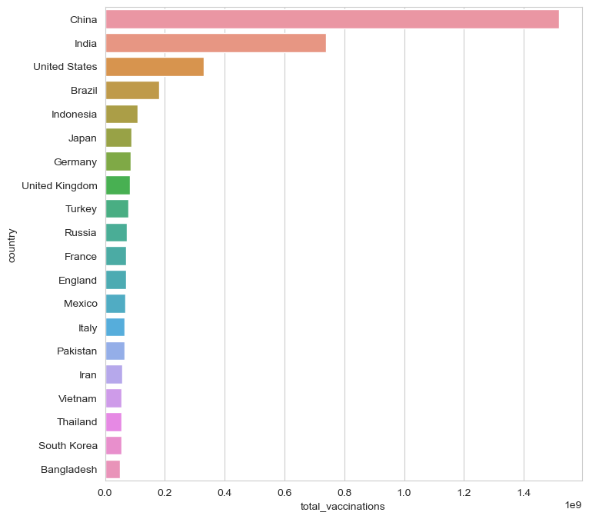
#Top countries with fully vaccinated peoples
df["Full_vaccinations(count)"]= df.groupby("country").people_fully_vaccinated.tail(1)
df.groupby("country")["Full_vaccinations(count)"].mean().sort_values(ascending= False).head(20)
country
India 828229455.0
United States 217498967.0
Brazil 160272858.0
Indonesia 158830466.0
Bangladesh 107712737.0
Pakistan 101881176.0
Japan 100633737.0
Mexico 79711762.0
Vietnam 77754108.0
Russia 72841232.0
Philippines 65804988.0
Germany 63142649.0
Iran 56810058.0
Turkey 52968985.0
France 52438706.0
Thailand 50159803.0
United Kingdom 49404026.0
Italy 47817555.0
South Korea 44482876.0
England 41501690.0
Name: Full_vaccinations(count), dtype: float64
#barplot visualization of top countries with most full vaccinations
sns.set_style("whitegrid")
plt.figure(figsize= (8,8))
ax= sns.barplot(x = x.values, y = x.index)
ax.set_xlabel("Fully vaccinated(count)")
plt.show()
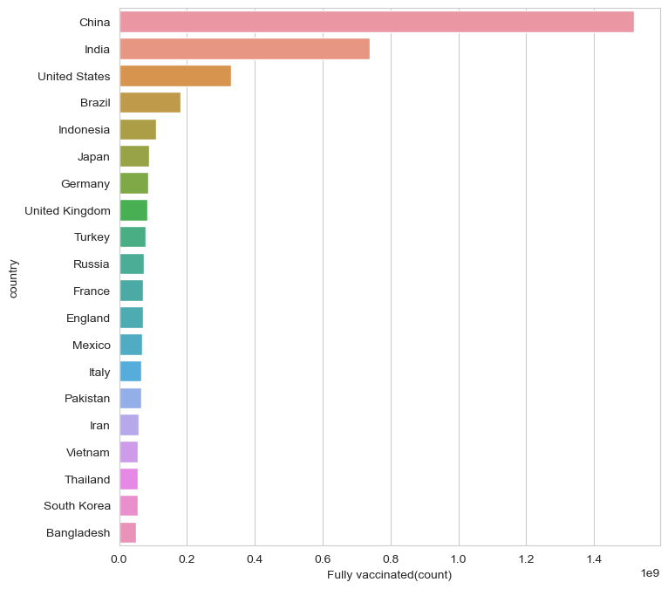
#Vaccine types
x=df.vaccines.unique()
y= list(x)
for i in y: print(i)
Johnson&Johnson, Oxford/AstraZeneca, Pfizer/BioNTech, Sinopharm/Beijing
Oxford/AstraZeneca, Pfizer/BioNTech, Sinovac, Sputnik V
Oxford/AstraZeneca, Sinopharm/Beijing, Sinovac, Sputnik V
Moderna, Oxford/AstraZeneca, Pfizer/BioNTech
Oxford/AstraZeneca
Oxford/AstraZeneca, Pfizer/BioNTech
Oxford/AstraZeneca, Pfizer/BioNTech, Sputnik V
CanSino, Moderna, Oxford/AstraZeneca, Pfizer/BioNTech, Sinopharm/Beijing, Sputnik V
Moderna, Oxford/AstraZeneca, Sinopharm/Beijing, Sinovac, Sputnik V
Pfizer/BioNTech
Johnson&Johnson, Moderna, Novavax, Oxford/AstraZeneca, Pfizer/BioNTech
Johnson&Johnson, Oxford/AstraZeneca, Pfizer/BioNTech
Johnson&Johnson, Moderna, Oxford/AstraZeneca, Pfizer/BioNTech, Sinopharm/Beijing, Sputnik Light, Sputnik V
Johnson&Johnson, Moderna, Oxford/AstraZeneca, Pfizer/BioNTech, Sinopharm/Beijing, Sinovac
Oxford/AstraZeneca, Pfizer/BioNTech, Sinopharm/Beijing
Sinopharm/Beijing, Sputnik V
Johnson&Johnson, Moderna, Oxford/AstraZeneca, Pfizer/BioNTech
Johnson&Johnson, Oxford/AstraZeneca, Pfizer/BioNTech, Sinovac
Moderna, Oxford/AstraZeneca, Pfizer/BioNTech, Sinopharm/Beijing
Johnson&Johnson, Oxford/AstraZeneca, Pfizer/BioNTech, Sinopharm/Beijing, Sputnik V
Moderna, Pfizer/BioNTech
Covaxin, Johnson&Johnson, Moderna, Oxford/AstraZeneca, Pfizer/BioNTech, Sinovac
Johnson&Johnson, Oxford/AstraZeneca
Johnson&Johnson, Moderna, Oxford/AstraZeneca, Pfizer/BioNTech, Sinopharm/Beijing
Johnson&Johnson, Oxford/AstraZeneca, Sinopharm/Beijing
Sinopharm/Beijing
Johnson&Johnson, Oxford/AstraZeneca, Sinopharm/Beijing, Sinovac
Covaxin, Oxford/AstraZeneca
CanSino, Oxford/AstraZeneca, Pfizer/BioNTech, Sinovac
CanSino, Sinopharm/Beijing, Sinopharm/Wuhan, Sinovac, ZF2001
Johnson&Johnson, Moderna, Oxford/AstraZeneca, Pfizer/BioNTech, Sinovac
Covaxin, Oxford/AstraZeneca, Sinopharm/Beijing
Moderna, Oxford/AstraZeneca, Sinopharm/Beijing, Sputnik V
Abdala, Soberana Plus, Soberana02
Johnson&Johnson, Moderna, Pfizer/BioNTech
Johnson&Johnson, Oxford/AstraZeneca, Pfizer/BioNTech, Sinopharm/Beijing, Sinovac, Sputnik V
Oxford/AstraZeneca, Pfizer/BioNTech, Sinopharm/Beijing, Sinovac
Covaxin, Johnson&Johnson, Oxford/AstraZeneca, Sinopharm/Beijing, Sinovac
Johnson&Johnson, Pfizer/BioNTech
Pfizer/BioNTech, Sinopharm/Beijing, Sputnik V
Oxford/AstraZeneca, Sputnik V
Moderna
Moderna, Oxford/AstraZeneca, Pfizer/BioNTech, Sputnik V
Oxford/AstraZeneca, Sinopharm/Beijing
Moderna, Oxford/AstraZeneca, Pfizer/BioNTech, Sinopharm/Beijing, Sputnik V
Johnson&Johnson, Moderna
Johnson&Johnson, Moderna, Oxford/AstraZeneca, Pfizer/BioNTech, Sputnik V
Pfizer/BioNTech, Sinovac
Johnson&Johnson, Moderna, Oxford/AstraZeneca, Pfizer/BioNTech, Sinopharm/Beijing, Sputnik V
Covaxin, Oxford/AstraZeneca, Sputnik V
Johnson&Johnson, Moderna, Novavax, Oxford/AstraZeneca, Pfizer/BioNTech, Sinopharm/Beijing, Sinovac
COVIran Barekat, Covaxin, FAKHRAVAC, Oxford/AstraZeneca, Razi Cov Pars, Sinopharm/Beijing, Soberana02, SpikoGen, Sputnik V
Oxford/AstraZeneca, Pfizer/BioNTech, Sinopharm/Beijing, Sputnik V
QazVac, Sinopharm/Beijing, Sputnik V
Johnson&Johnson, Oxford/AstraZeneca, Pfizer/BioNTech, Sinopharm/Beijing, Sinovac, Sputnik Light, Sputnik V
Johnson&Johnson, Moderna, Novavax, Pfizer/BioNTech
Oxford/AstraZeneca, Pfizer/BioNTech, Sinopharm/Beijing, Sinovac, Sputnik V
Pfizer/BioNTech, Sinopharm/Beijing
CanSino, Oxford/AstraZeneca, Pfizer/BioNTech, Sinopharm/Beijing, Sinovac
CanSino, Johnson&Johnson, Moderna, Oxford/AstraZeneca, Pfizer/BioNTech, Sinovac, Sputnik V
Abdala, Johnson&Johnson, Oxford/AstraZeneca, Pfizer/BioNTech, Soberana02, Sputnik Light, Sputnik V
Oxford/AstraZeneca, Pfizer/BioNTech, Sinovac
CanSino, Covaxin, Moderna, Oxford/AstraZeneca, Pfizer/BioNTech, Sinopharm/Beijing, Sinovac, Sputnik V
Johnson&Johnson, Moderna, Oxford/AstraZeneca, Pfizer/BioNTech, Sinopharm/Beijing, Sinovac, Sputnik Light, Sputnik V
Covaxin, Moderna, Oxford/AstraZeneca, Pfizer/BioNTech, Sinopharm/Beijing, Sinovac, Sputnik V
EpiVacCorona, Sputnik V
Johnson&Johnson, Moderna, Oxford/AstraZeneca, Pfizer/BioNTech, Sinopharm/Beijing, Sinovac, Sputnik V
Pfizer/BioNTech, Sputnik V
Oxford/AstraZeneca, Sinopharm/Beijing, Sputnik V
Moderna, Pfizer/BioNTech, Sinopharm/Beijing, Sinovac
Johnson&Johnson, Moderna, Novavax, Oxford/AstraZeneca, Pfizer/BioNTech, Sputnik V
Johnson&Johnson, Oxford/AstraZeneca, Pfizer/BioNTech, Sinopharm/Beijing, Sinovac
Johnson&Johnson, Oxford/AstraZeneca, Sinopharm/Beijing, Sinovac, Sputnik Light, Sputnik V
Medigen, Moderna, Oxford/AstraZeneca, Pfizer/BioNTech
Moderna, Oxford/AstraZeneca, Pfizer/BioNTech, Sinovac, Sputnik V
Johnson&Johnson, Pfizer/BioNTech, Sinopharm/Beijing
Moderna, Oxford/AstraZeneca, Pfizer/BioNTech, Sinopharm/Beijing, Sinovac
Pfizer/BioNTech, Sinovac, Turkovac
EpiVacCorona, Oxford/AstraZeneca, QazVac, Sinopharm/Beijing, Sputnik V, ZF2001
Oxford/AstraZeneca, Pfizer/BioNTech, Sinopharm/Beijing, Sinopharm/Wuhan, Sputnik V
Moderna, Oxford/AstraZeneca, Pfizer/BioNTech, Sinovac, Sputnik Light, Sputnik V, ZF2001
Abdala, Sinopharm/Beijing, Sinovac, Soberana02, Sputnik Light, Sputnik V
Abdala, Moderna, Oxford/AstraZeneca, Pfizer/BioNTech, Sinopharm/Beijing, Sputnik V
Johnson&Johnson, Oxford/AstraZeneca, Sinovac
#most common vaccines
df.vaccines.value_counts()
vaccines
Johnson&Johnson, Moderna, Oxford/AstraZeneca, Pfizer/BioNTech 7608
Moderna, Oxford/AstraZeneca, Pfizer/BioNTech 6263
Oxford/AstraZeneca 6022
Oxford/AstraZeneca, Pfizer/BioNTech 4629
Johnson&Johnson, Moderna, Novavax, Oxford/AstraZeneca, Pfizer/BioNTech 3564
...
Johnson&Johnson, Oxford/AstraZeneca, Sinovac 312
Moderna, Oxford/AstraZeneca, Pfizer/BioNTech, Sinovac, Sputnik V 311
Johnson&Johnson, Moderna 251
Johnson&Johnson, Pfizer/BioNTech, Sinopharm/Beijing 228
EpiVacCorona, Oxford/AstraZeneca, QazVac, Sinopharm/Beijing, Sputnik V, ZF2001 190
Name: count, Length: 84, dtype: int64
plt.figure(figsize=(15,15))
sns.countplot(y= "vaccines",data= df)
plt.show()
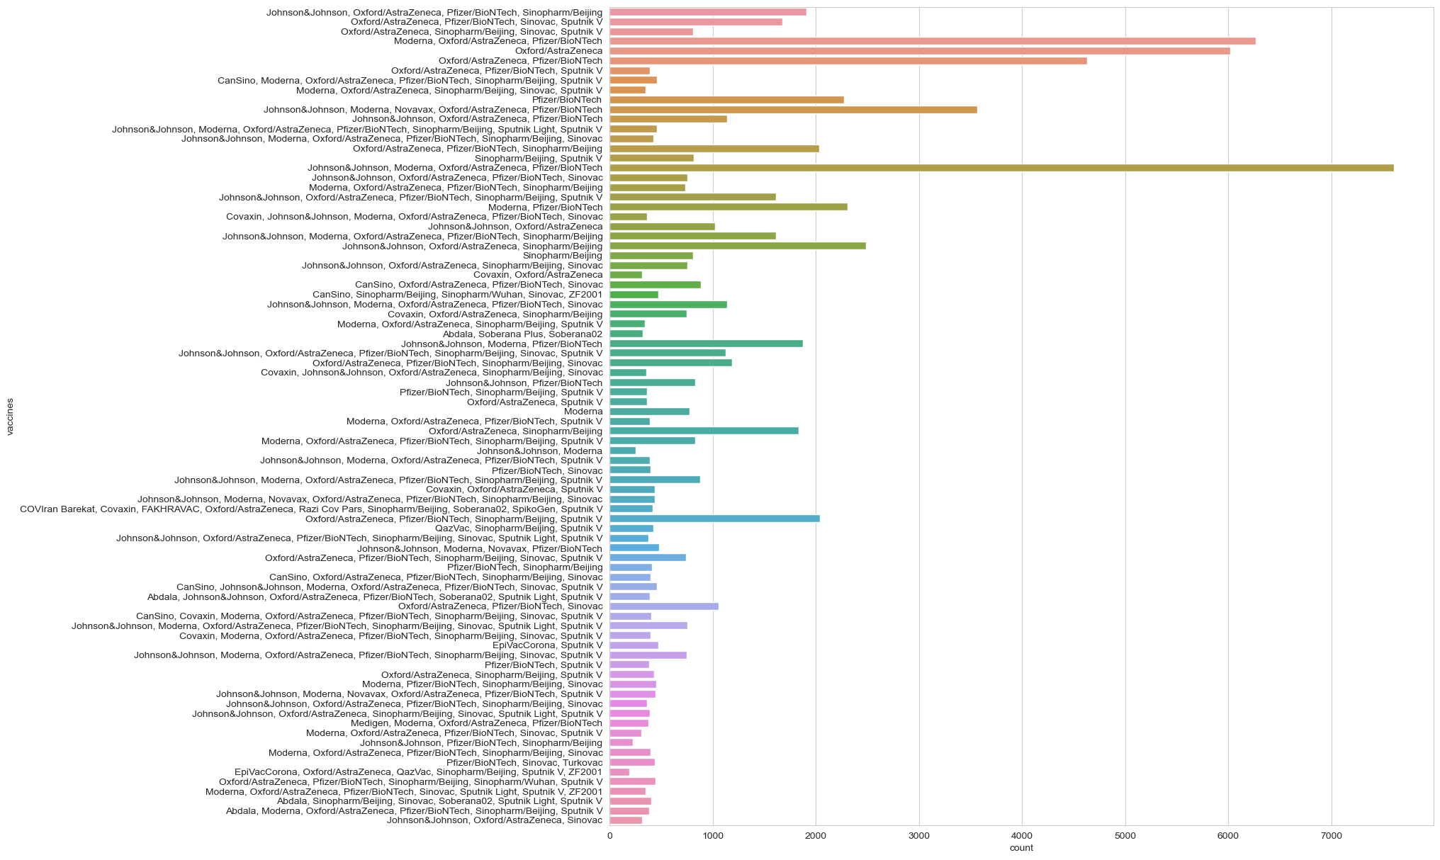
#daily vaccinations
x= df.groupby("date").daily_vaccinations.sum()
plt.figure(figsize= (15,5))
sns.lineplot(x= x.index,y= x.values)
plt.show()
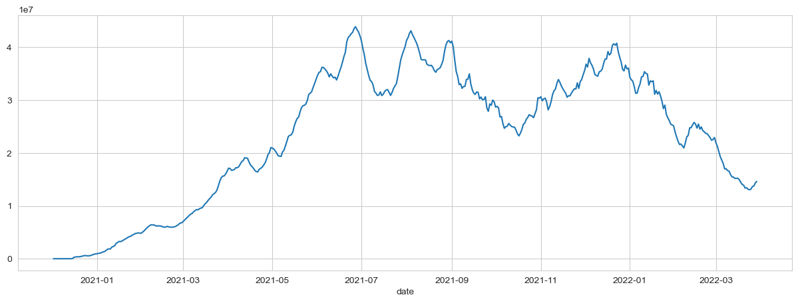
fig,ax = plt.subplots(figsize = (12,5))
sns.boxplot(data =df, x = 'people_vaccinated', y = 'people_fully_vaccinated', orient = 'h').set(title = 'full vs total vaccination');
#total vaccinations
plt.figure(figsize= (15,5))
sns.lineplot(x= "date",y= "total_vaccinations",data= df)
plt.show()
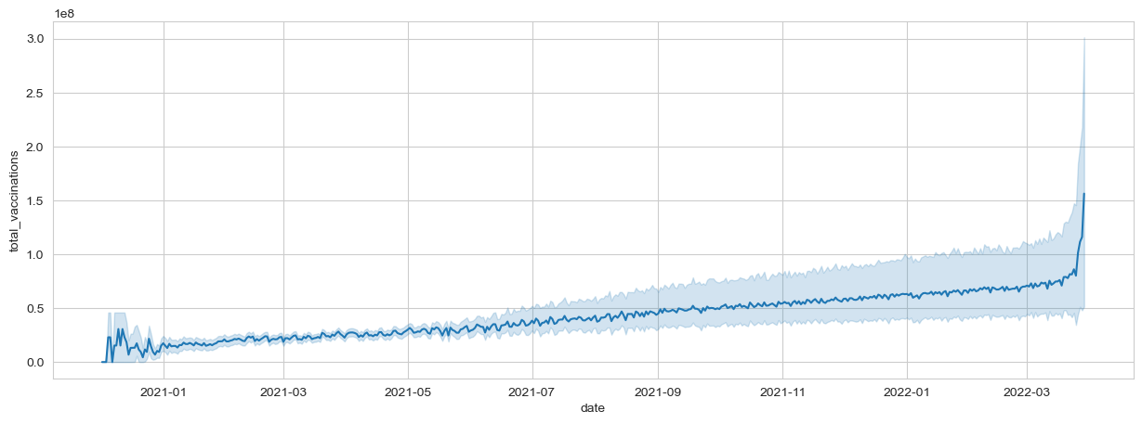
#Countries with best daily average vaccinations
x= df.groupby("country").daily_vaccinations.mean().sort_values(ascending= False).head(20)
x
country
China 6.930368e+06
India 4.175994e+06
United States 1.191727e+06
Brazil 9.435287e+05
Indonesia 8.462893e+05
Japan 6.215795e+05
Bangladesh 5.453055e+05
Pakistan 5.430051e+05
Vietnam 5.310949e+05
Mexico 4.134253e+05
Germany 3.761575e+05
Philippines 3.665658e+05
Iran 3.535194e+05
Russia 3.480843e+05
Turkey 3.351917e+05
Thailand 3.251471e+05
United Kingdom 3.140841e+05
France 3.104963e+05
South Korea 3.042512e+05
Italy 2.970580e+05
Name: daily_vaccinations, dtype: float64
#daily vaccinations barplot
plt.figure(figsize= (8,8))
ax= sns.barplot(x= x.values,y= x.index)
ax.set_xlabel("daily vaccinations(avg)")
plt.show()
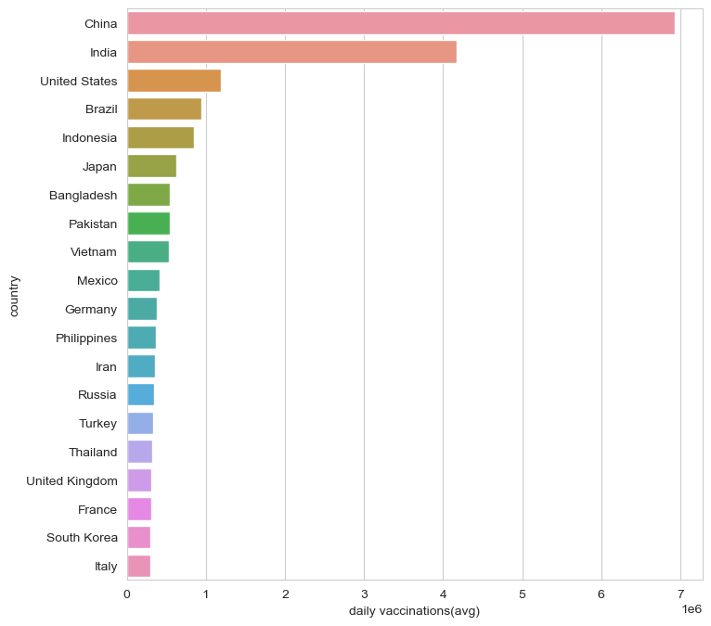
#vaccination per hundred top countries
df["Total_vaccinations_per_hundred"]= df.groupby("country").total_vaccinations_per_hundred.tail(1)
x= df.groupby("country")["Total_vaccinations_per_hundred"].mean().sort_values(ascending= False).head(10)
plt.figure(figsize= (8,8))
ax= sns.barplot(x= x.values,y= x.index)
ax.set_xlabel("vaccinations per hundred")
plt.show()
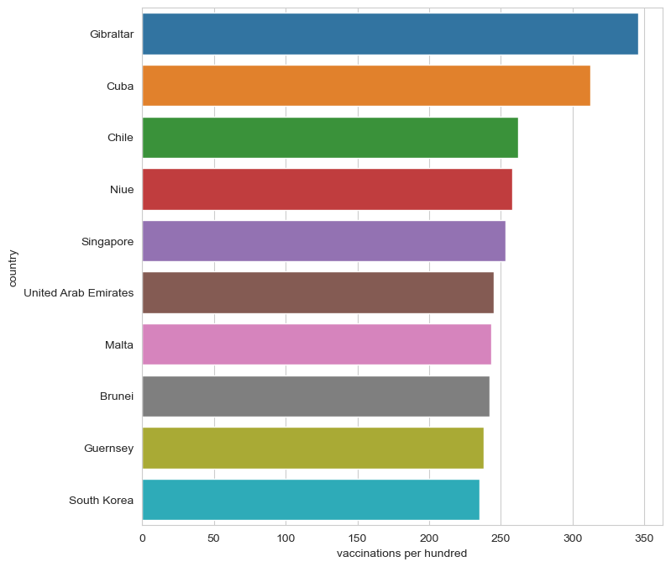
#daily vaccinations per million top countries
df.groupby("country")["daily_vaccinations_per_million"].mean().sort_values(ascending= False).head(20)
country
Falkland Islands 21185.393939
Saint Helena 13915.164835
Tokelau 12718.106195
Pitcairn 10891.797619
Niue 10109.509434
Cuba 9955.943333
Gibraltar 8000.463470
Bonaire Sint Eustatius and Saba 7412.000000
Bhutan 7241.676880
Brunei 6906.782857
Turkmenistan 6618.888889
South Korea 5930.227273
Uruguay 5829.491139
Chile 5764.154525
Singapore 5585.536424
Malta 5553.986207
Taiwan 5545.517426
Guernsey 5437.624113
Australia 5422.241895
Vietnam 5410.000000
Name: daily_vaccinations_per_million, dtype: float64
#daily vaccination per million
plt.figure(figsize= (15,5))
sns.lineplot(x= "date",y= "daily_vaccinations_per_million",data= df)
plt.show()
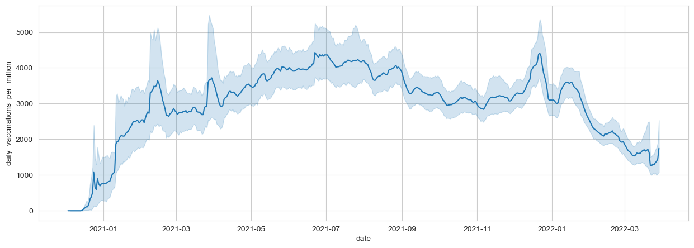
#people fully vaccinated
plt.figure(figsize= (15,5))
sns.lineplot(x= "date",y= "people_fully_vaccinated",data= df)
plt.show()
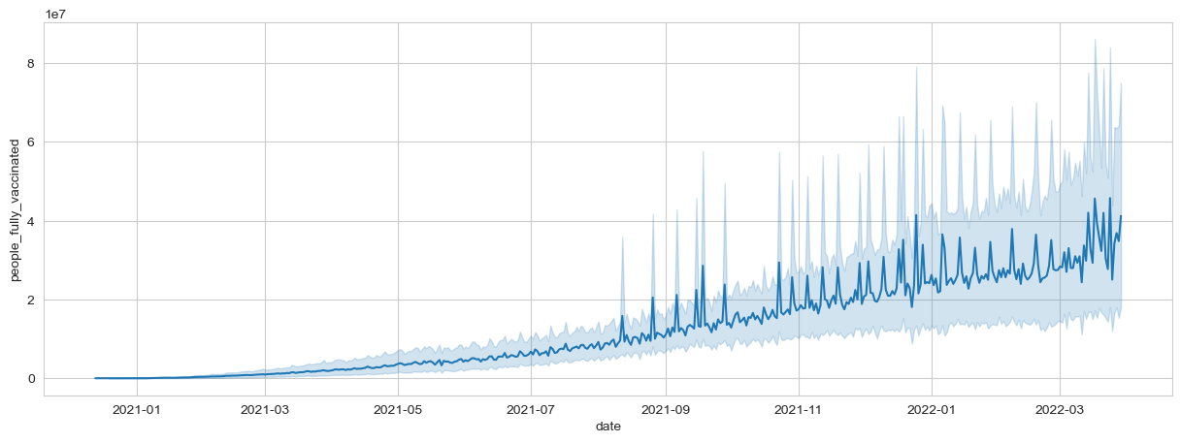
#covid 19 vaccinations INDIA
#daily vaccinations in India
plt.figure(figsize= (15,5))
sns.lineplot(x= "date",y= "daily_vaccinations",data= df[df.country== "India"])
plt.show()
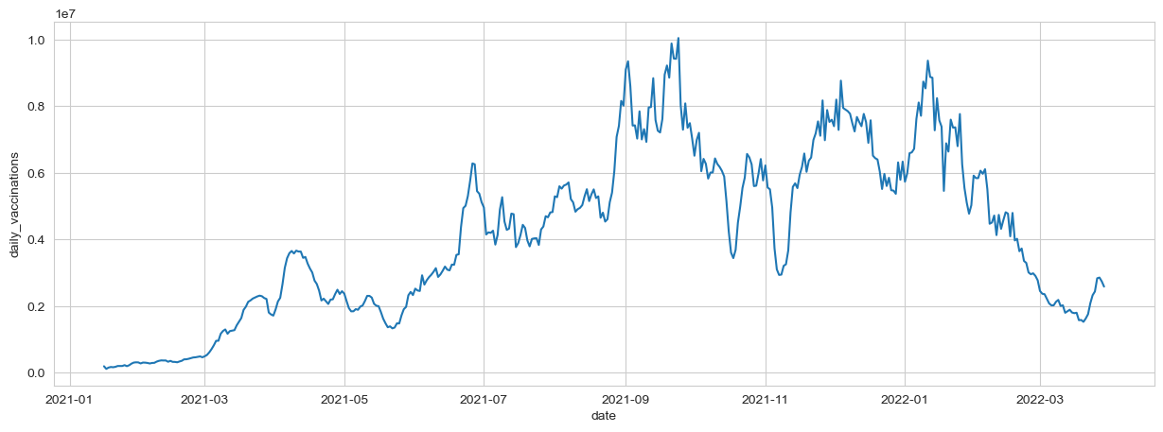
#Total vaccinations in India
plt.figure(figsize= (15,5))
sns.lineplot(x= "date",y= "total_vaccinations",data= df[df["country"]=="India"])
plt.show()
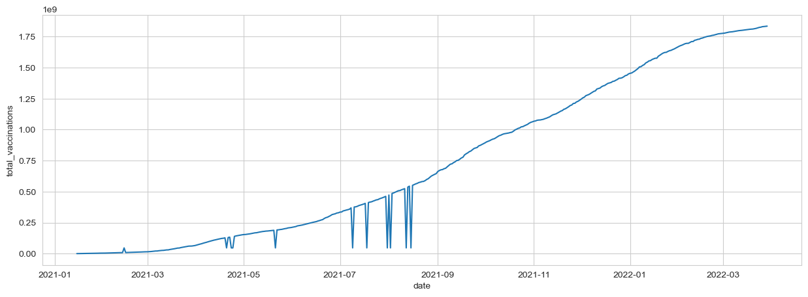
#full vaccinations in India
plt.figure(figsize= (15,5))
sns.lineplot(x= "date",y= "people_fully_vaccinated",data= df[df["country"]=="India"])
plt.show()
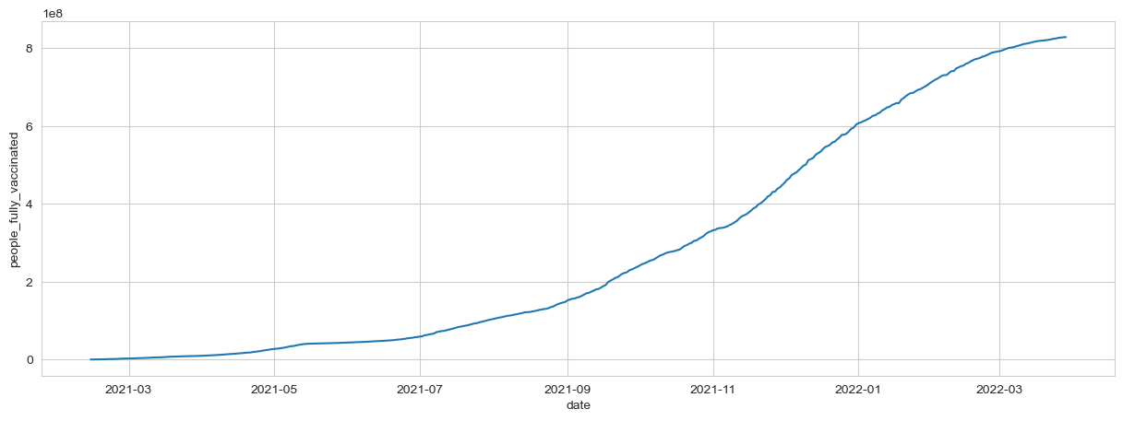
#people_vaccinated per hundred in India
plt.figure(figsize= (15,5))
sns.lineplot(x= "date",y= "people_vaccinated_per_hundred",data= df[df["country"]=="India"])
plt.show()
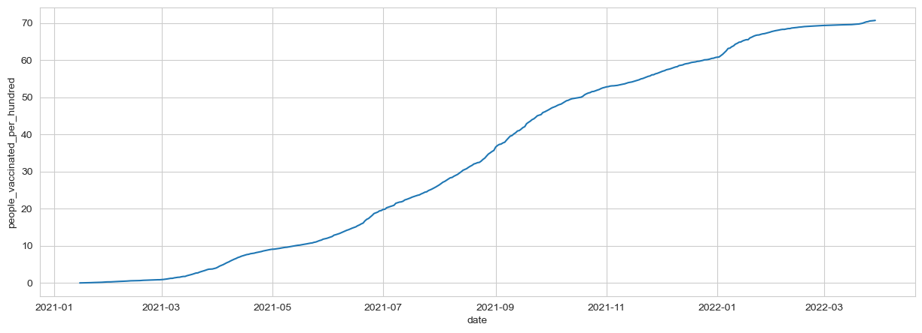
#preferred vaccine in India
x= df[df["country"]=="India"]
z= x.vaccines.value_counts()
c= list(z.index)
c
['Covaxin, Oxford/AstraZeneca, Sputnik V']
#COMPARING TOP 5 COUNTRIES WITH MOST VACCINATIONS
df.groupby("country")["total_vaccinations"].mean().sort_values(ascending= False).head()
country
China 1.517780e+09
India 7.379169e+08
United States 3.291165e+08
Brazil 1.816675e+08
Indonesia 1.088421e+08
Name: total_vaccinations, dtype: float64
#creating dataframe for top 5 vaccinated countries
x= df.loc[(df.country== "United States") | (df.country== "China")| (df.country== "India")| (df.country== "Unted Kingdom")|(df.country== "England")]
#total vaccination comparison
plt.figure(figsize= (15,5))
sns.lineplot(x= "date",y= "total_vaccinations" ,data= x,hue= "country")
plt.show()
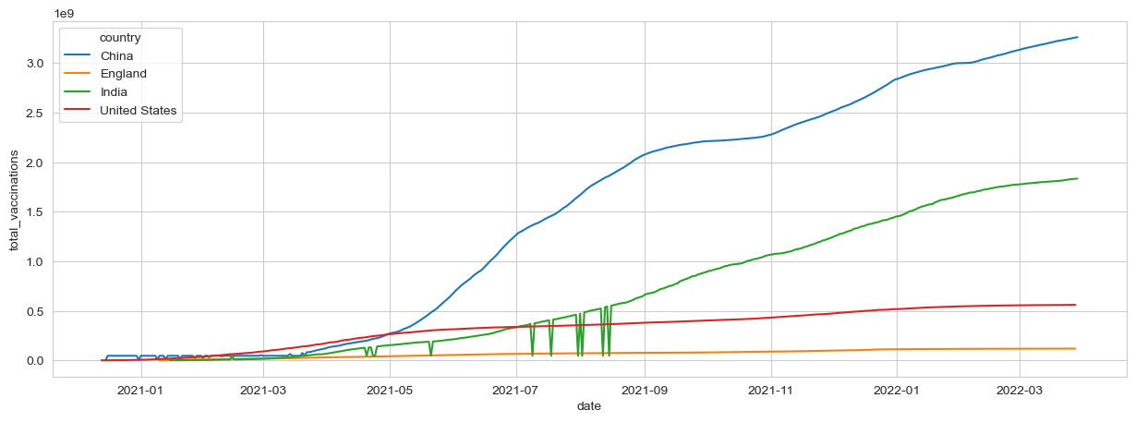
#daily vaccination comparison
plt.figure(figsize= (15,5))
sns.lineplot(x= "date",y= "daily_vaccinations" ,data= x,hue= "country")
plt.show()
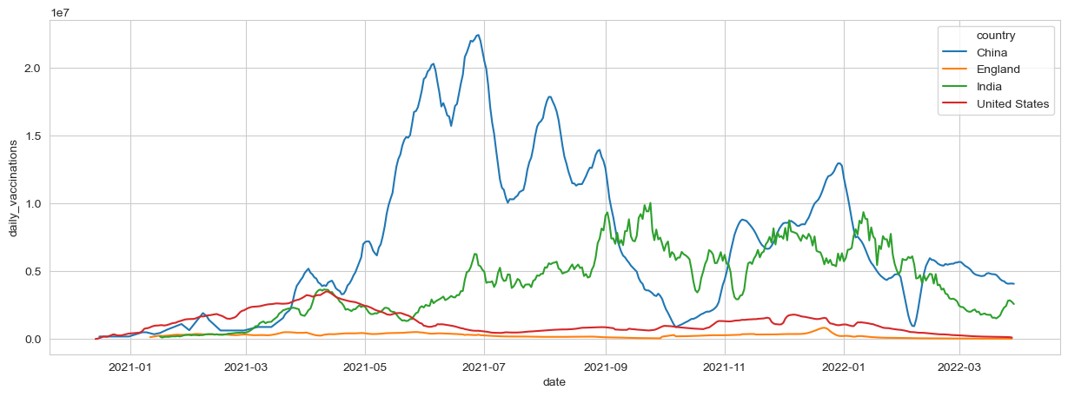
#full vaccinations comparison
plt.figure(figsize= (15,5))
sns.lineplot(x= "date",y= "people_fully_vaccinated" ,data= x,hue= "country")
plt.show()
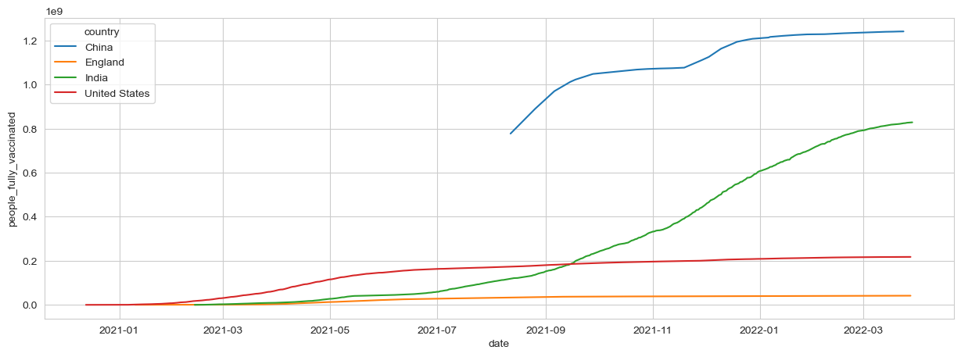
#daily vaccination per million comparison
plt.figure(figsize= (15,5))
sns.lineplot(x= "date",y= "daily_vaccinations_per_million" ,data= x,hue= "country")
plt.show()
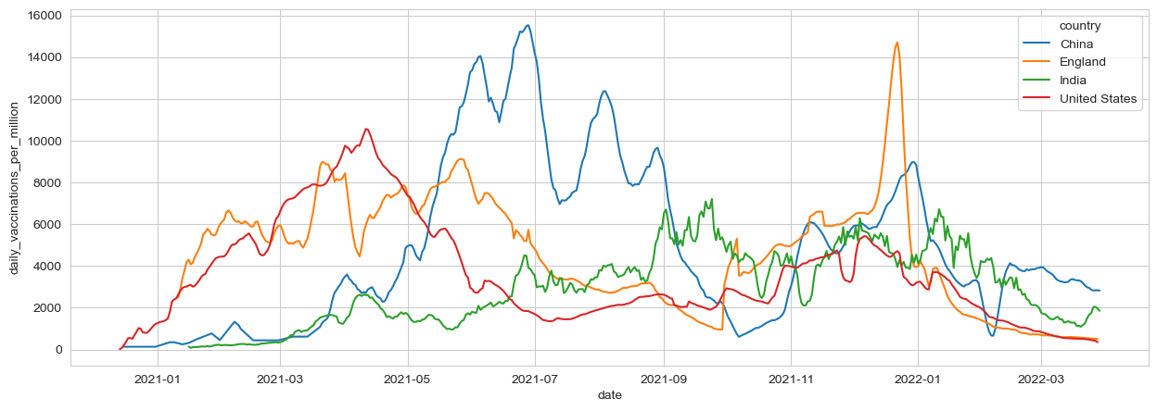

Conclusion

From the data it is known that daily vaccination count is reduced by 2023 and many people still need to vaccinate which is recognised from seeing total vaccination plot and daily vaccination plot between countries

THANK YOU

